**REPORT ON FIFA 2023 FOOTBALL RATINGS**

**STUDENT ID: 21019292**

**NAME: OLUWADAMILOLA ABIMBOLA ORIMOOGUNJE**

**COURSE: APPLIED DATASCIENCE 1**

**Link to Dataset:** https://www.kaggle.com/datasets/mohammedessam97/fifa-23-fut-players-dataset/download?datasetVersionNumber=1

This dataset includes players data for the FIFA 2023 Football Ratings.

Line plot of Players showing some of their skills

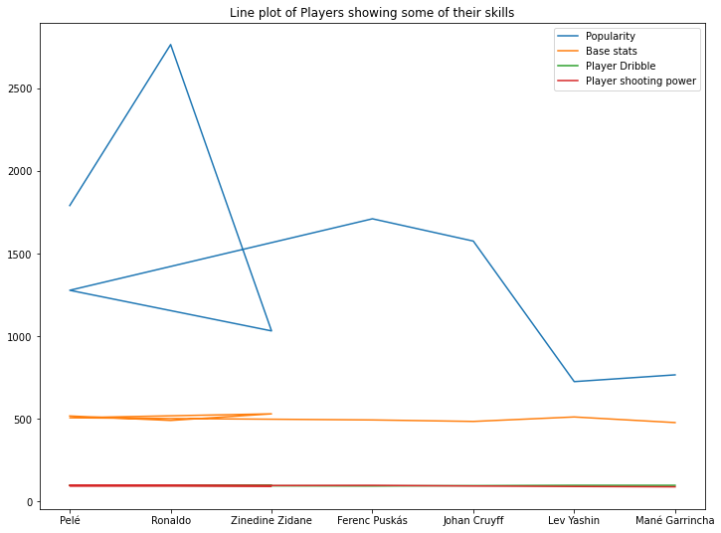

**Fig (1)**

**Explanation for Fig(1):**

This multiple line plots shows that players like Pele , Ronaldo and Zinedine Zidane have the highest popularity compared to other players. Overall, it can be seen that for skills like Base stats, Player dribble and Player shooting power the players kind of have similar rate of skills but only popularity differs.

Bar chart showing the Best Ratings of Players

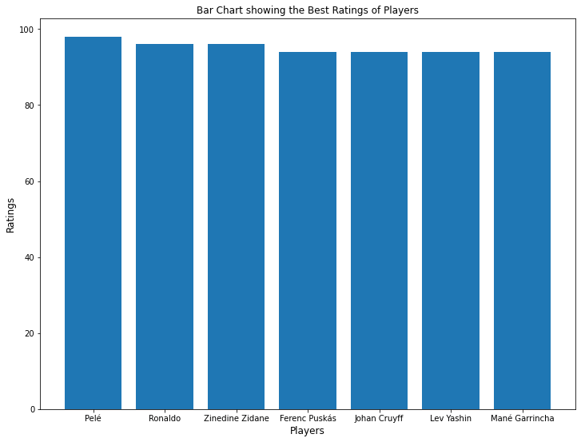

**Fig (2)**

**Explanation for Fig (2):**

This Bar chart shows that Pele has the highest ratings as a Player but we can also see the Ronaldo and Zinedine Zidane are not far off either. I picked this type of graph because the scales and figures are easy to read and also because it shows all the categories present in a distribution.

Subplot pie chart showing the country with the best player in some of the skills

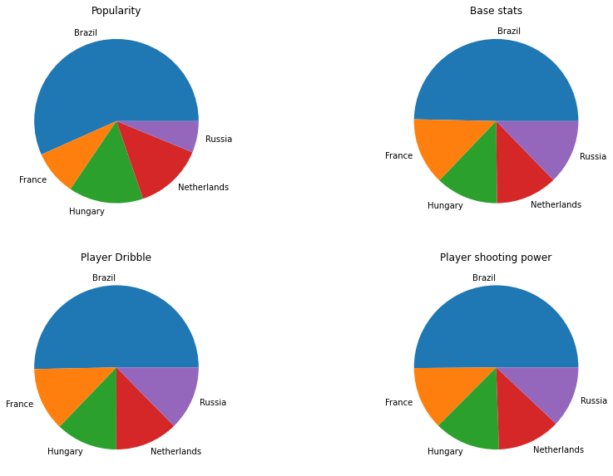

**Fig(3)**

**Explanation Fig (3):**

This subplot pie chart depicts information about the country that has best Players in some skills. We can see that Brazil is the country with the best players in the skills in this subplot pie chart, followed by the other countries. I decided to use a pie chart as part of my visualization for this assignment because my data is large and pie chart is a good way to represent large data in a simple graphical manner and it is way simpler than other forms of charts.